C09185 - SWIPE X MISSING TRANSACTIONS

**Change Number:** C09185

**Solution Design Document**

**03-Dec-2024**

**Version**  **1.0**

This document contains confidential information and is supplied under the terms of an Agreement with the KCB Bank Kenya Ltd., which provides that it is intended only for the individuals or entity named here in. Disclosure, copying or distribution of the contents of this document is strictly prohibited.

# Proprietary Notice

This document contains information specific and confidential to KCB Bank Kenya Ltd. Reading this document is an undertaking to observe the confidentiality and copyright of the KCB Bank Kenya Ltd information and to undertake that the information contained herein will not be reproduced in whole or part, discussed, or distributed under any circumstances without the prior written permission of KCB Bank Kenya Ltd.

# Approvals and Revision History

## Document Approval

| **Version** | **Name** | **Role/Department** | **Signature** | **Date** |
| --- | --- | --- | --- | --- |
| 1.0 | Jackson Akidua Mulutu | Domain Architect/GEA |  | 04/12/2024 |
| 1.0 | John Murimi Nyaga | Solutions Architect/GEA |  |  |

## Revision History

| **Date** | **Version** | **Description of Change** | **Change done by** | **Department/Unit** |
| --- | --- | --- | --- | --- |
| 03-Dec-2024 | 1.0 | Initial draft solution design | John Murimi Nyaga | GEA |
|  |  |  |  |  |
|  |  |  |  |  |
|  |  |  |  |  |
|  |  |  |  |  |

Table of Contents

Proprietary Notice 2

Approvals and Revision History 2

Document Approval 2

Revision History 2

1. Problem Background 5

1.1 High-Level Architecture 5

1.2 Service Sequence Flow 7

2. Process Flows 7

2.1 Transaction flow 7

3. Service Interfaces 7

3.1 Interface 8

3.1.1 Sequence Flow 8

3.1.2 Interface Details 8

3.1.3 Interface Design NA 8

3.1.4 Response Schema 8

3.1.5 Request Schemer 8

3.1.6 Response Schemer 8

4. Assumptions 8

5. Risks 8

6. In scope Items of work 9

7. Out of scope 9

8. MIS / Reporting 9

9. Security 9

10. Reference Documentation 11

Appendixes 11

No table of figures entries found.

# Problem Background

**Introduction**

ABSA, our partner, uses Swipe X, a portal that mirrors transactions from the T24 system, allowing them to review all transactions conducted at KCB. Since ABSA lacks direct access to T24, Swipe X serves as their primary tool for transaction monitoring. However, there have been cases where transactions appear successfully processed on ABSA’s side but are missing in Swipe X. This issue arises when ABSA finalizes a transaction based on the notification they receive, despite the transaction not being recorded in T24.

**Problem statement**

A significant problem exists in the transaction processing workflow between ABSA, Swipe X and T24, where transactions are marked as successful on Swipe X hence the transaction is completed by ABSA’s side yet there is no record on T24. This issue occurs when ABSA finalizes transactions based on notifications received, yet those transactions are not recorded in the T24 system.

*Attached BRD:*

## High-Level Architecture

**HLD (Existing architecture)**

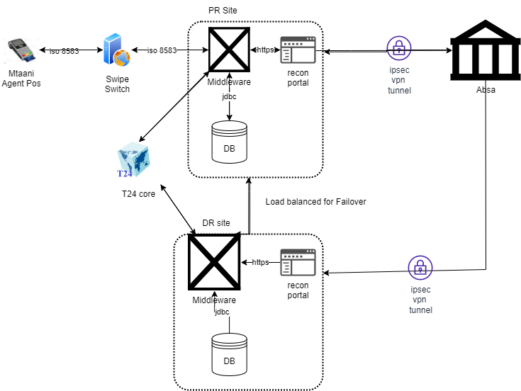

*Fig: Image showing the existing architecture of the agency banking interpolabilty integration*

***Components***

From the diagram, the following are the core components involved in the solution and their functions;

**KCB Mtaani POS** - Used to enable agents to initiate the requisite transactions

**Swipe Switch** - Route requests from POS to middleware

**Middleware** - Suite of services to be developed with the core aim of authenticating, transforming, forwarding transaction requests from the switch to the partner bank and logging responses and transaction statuses. It will also fetch and transform the daily recon files

**T24. Core Banking Solution.** Used to post the FT transactions involved in the solution

**Recon Portal.** Front end portal. To be developed and exposed to the partners. Approved Partners will be created and sent credentials to perform the following functions:

* *Log in*
* *View the daily recon files*
* *Download Recon files in CSV format*

**Architecture implication in this change.**

In the flow in production for both Withdraw and cash deposit the advise notification sent to ABSA to complete DR/CR processes is sent before KCB does the CR/DR on their side.

This change seeks to have KCB do the CR/DR is first and if successful then request notification for CR/DR advise is sent to ABSA.

This will reduce the descrepancies in the transactions between KCB and partner.

## Service Sequence Flow Solution flow description (As it should be)

**i. Universal Menu on Bitel POS:**

Has Cash Deposit and Cash withdrawal Options under which will have Partner Banks for the agent to select the Bank of the customer and Deposit/Withdraw Cash.

ii. **Cash Deposit to have the following Fields for data capture:**

Account/Card Number (for Crediting)

Amount (amount to be credited)

Payment details (Purpose or Narration)

iii. **Cash Withdrawal menu to have - (With Card):**

Card Number/Account Field (this is the account to withdraw from)

Amount (amount to be withdrawn) Field

Payment details (Purpose or Narration) Field

iv. **Cash Withdrawal menu to have (Card-less):**

Mobile Number Field

Authorization Code Field

Amount Field

v. **Validation Request functionality from POS to the Backend (OCP- Swipe)** to the Partner Bank for account validation with the other Bank once the customer submits cash withdrawal Request. This should fetch account name for display to the customer for confirmation before the transaction is committed (Synchronous Communication).

vi. **Cash Deposit Function:** which is invoked after successful validation.

Terminal submits Request to OCP which calls on the FT Micro Service for Cash Deposit to T24. Agent Float account will be debited the principal amount to be transacted and Current account credited.

Commission account will be debited, and the agent credited the commission.

T24 will respond to OCP which will call the Partner Bank via the Gateway to credit the customer’s account of the prescribed amount (Synchronous Communication between Bitel & OCP, Asynchronous communication from OCP to Partner Bank via Gateway).

N/B: Use Block Session at OCP level to hold a session when using a hybrid of Synch/Async)

vii. **Cash Withdrawal** Function that will send the request to the Partner Bank via OCP and the Gateway directly for validations and Subsequent DR/CR from the customer account to suspense account

viii. **Response to the channel (POS) from OCP after successful FT.**

ix. A Notification service to partner bank in synchronous manner.

x. Receipt to be generated Partner Banks to have the Name of their Bank included on the Receipt.

xi. **Partner bank Customers** to receive an sms notification based on the phone number provided during the transaction. Partner bank to send the notifications

xii. **Biller Payments*.** Used to enable Absa Customers to make payments to a defined list of Billers. Proposed Journey is as follows:

a. **Absa Customer** will visit visit KCB Mtaani Agent with a request to make a biller payment. Agent will use POS to select the appropriate Absa Biller Menu and provide the following:

i. Biller ID

ii. Customer account number

iii. Amount

b. validation will be done via the provided biller validation endpoint and return a response as to whether the biller Id and customer account is valid

c. If Validation is successful Absa will return a successful response code and the name of the biller selected

d. **Agent** will proceed to show user whether the details are correct as shown on the poss and press confirm if okay. Request flow will be POS-Switch-Middleware-Absa. Absa ISO Biller API to be used in the fulfillment request.

e. **On successful fulfillment**, Successful response will be displayed on POS and Biller account credited on Absa side. Successful custom notifications to be sent by ABSA on the same

**Sequence diagrams of business processes (As it should be)**

Sequence Diagram - Cash Deposit 

Sequence Diagram - Cash Withdrawal from Partner Bank 

Sequence Diagram - Daily Transactions File Report and Float visibility



Sequence Diagram- Bill Payment Flow 

# Process Flows

## Transaction flow

**FTs happening on Deposits**

* Receive cash from customer
* Debit Agent account-KCB
* Credit ABSA settlement account-KCB
* Charges-Debit ABSA settlement-KCB
* Credit agent commission (KCB)
* Credit PL(KCB)
* Debit ABSA settlement account-charges (ABSA)
* Credit ABSA fee suspense account (ABSA)
* Debit ABSA settlement account-ABSA (mirror account)
* Credit ABSA customer account-ABSA

**FTs on Withdrawals**

* Debit customer account-ABSA
* Credit settlement account-ABSA (mirror account)
* Debit customer account with charges (ABSA)
* Credit ABSA fee suspense account-charges
* Debit KCB settlement account-charges
* Debit settlement account-withdrawal amount-KCB
* Credit agent account-withdrawal amount-KCB
* Credit agent account with commission (KCB)
* Credit Bank PL with commission (KCB)
* Agent pays customer cash

# Service Interfaces

### Interface Agency Banking Interoperability API

### APIs

### Cardless deposit - synchronous

### Account validation – synchronous

### Card based deposit – synchronous

### Card based withdraw – synchronous

### The following attachment highlights the agreed upon fields and endpoints that will be used

### 

|  |
| --- |
|  |

### Sequence Flow

As highlighted in the sequence diagram

### Interface Details

Attached in the API specification document

### Sequence Flow

As shown in sequence diagrams section

### Interface Details

As attached

### Interface Design

As attached

### Request Schemer

As attached

### Response Schemer

As attached above

### Interface The KCB Mtaani Agent-Absa integration will be via iso 8583 TCP/IP endpoints secured over an IPsec VPN tunnel.

### The following attachment highlights the agreed upon fields and endpoints that will be used

|  |
| --- |
|  |

### 

### Sequence Flow

As highlighted in the sequence diagram

### Interface Details

Attached in the ISO specification document

### Sequence Flow

As shown in sequence diagrams section

### Interface Details

As attached

### Interface Design

As attached

### Request Schemer

As attached

### Response Schemer

As attached

# Assumptions

The components needed by this system flow to work but are not part of the change will be working as expected.

# Risks

Failure of transactions uniformity between partners and KCB

# In scope Items of work

Bitel POS  
Middleware services (OCP)

# Out of scope

Items that are part of change, but implementation will not occur on them

# MIS / Reporting A daily reconciliation report will be availed on a recon portal to enable the partners to login, view and download a report containing the following parameters;

# Timestamp

# Transaction type (debit or withdrawal)

# Amount

# Unique ref number

# Details of card that has transacted

# Security

KCB security guidelines have already been applied in the existing architecture implementation. (Attached)

*KCB group security guidelines:*



# Other non-functional requirements

**Performance and Scalability Requirements**

The system should process transactions between T24 and Swipe X in real-time with minimal latency to ensure synchronization.

**Portability and Compatibility Requirements**

The solution must be compatible with the existing T24 and Swipe X platforms.

**Reliability, Maintainability & Availability Requirements**

The system must have a 99.9% uptime, ensuring high availability for ABSA and other partners.

**Logging & Audit Requirements**

All transaction activities, including DR/CR postings and notifications, should be logged for audit purposes.

Logs should capture transaction ID, timestamp, status, and any error messages to facilitate troubleshooting and analysis.

**Monitoring & Alerts Requirements**

The system should be hooked to a monitoring tool i.e. Instana

# Acronyms & Key Terms

| **Acronym or Term** | **Definition** |
| --- | --- |
| OCP | Open Shift Container Platform |
| T24 | KCB Temenos CBS |
| POS | Point of Sale |
|  |  |

# Appendixes Project Breeze - Agency Interoperability.postman_collection 1 1

